MAMBENCH PROCESS DOCUMENTATION

Step 1:
Dataset preparation
Datasets used for Phase 1-
Category | Phase 1 action
LoCoMo | Clean + normalize
LongMemEval | Clean + normalize
MSC | Clean + normalize
Conversation Chronicles | Clean + normalize
API-Bank | Inspect + normalize for tool/API task representation
ToolBench | Inspect + normalize
StrategyQA | Inspect + normalize
WebShop | Inspect + normalize
SWE-bench Verified | Inspect + normalize
τ-bench / τ²-bench | Inspect + normalize
EHRAgent | Inspect + normalize
MIMIC-III / eICU | Inspect + prepare only if we confirm they're needed/usable
Hidden in Memory | Prepare sleeper-evaluation data
MPBench | Prepare benchmark/attack scenarios
AgentPoison | Prepare attack specification/data
MINJA | Prepare attack specification/data
DSRM | Prepare attack specification/data
MemoryGraft | Prepare attack specification/data
FARMA | Prepare attack specification/data
Sleeper Dataset Generator | Prepare generation configuration/templates
MemSecBench | Prepare comparison/evaluation resources
MEMSAD | Prepare comparison/evaluation resources
MemAudit | Prepare comparison/evaluation resources
A-MemGuard | Prepare baseline/defense comparison resources
ASB | Prepare evaluation resources
AgentDojo | Prepare evaluation environment/resources
InjecAgent | Prepare injection/evaluation resources

- Since all datasets are being used for different purposes in this project, we are preparing/ pre processing it according to its purpose.
- We keep track of the source, version, licensing, location, size, access status and its purpose for every dataset to keep everything verified, inaccessible datasets will not be included.
- We then proceed with inspecting ,cleaning the datasets and then normalizing the datasets.
- We preserve provenance wherever possible and keep track of the source as it is one of the main areas of our research.
- We distinguish what we got and what we created and then validate it, again to maintain integrity of the research.
- Make the project reproducible.
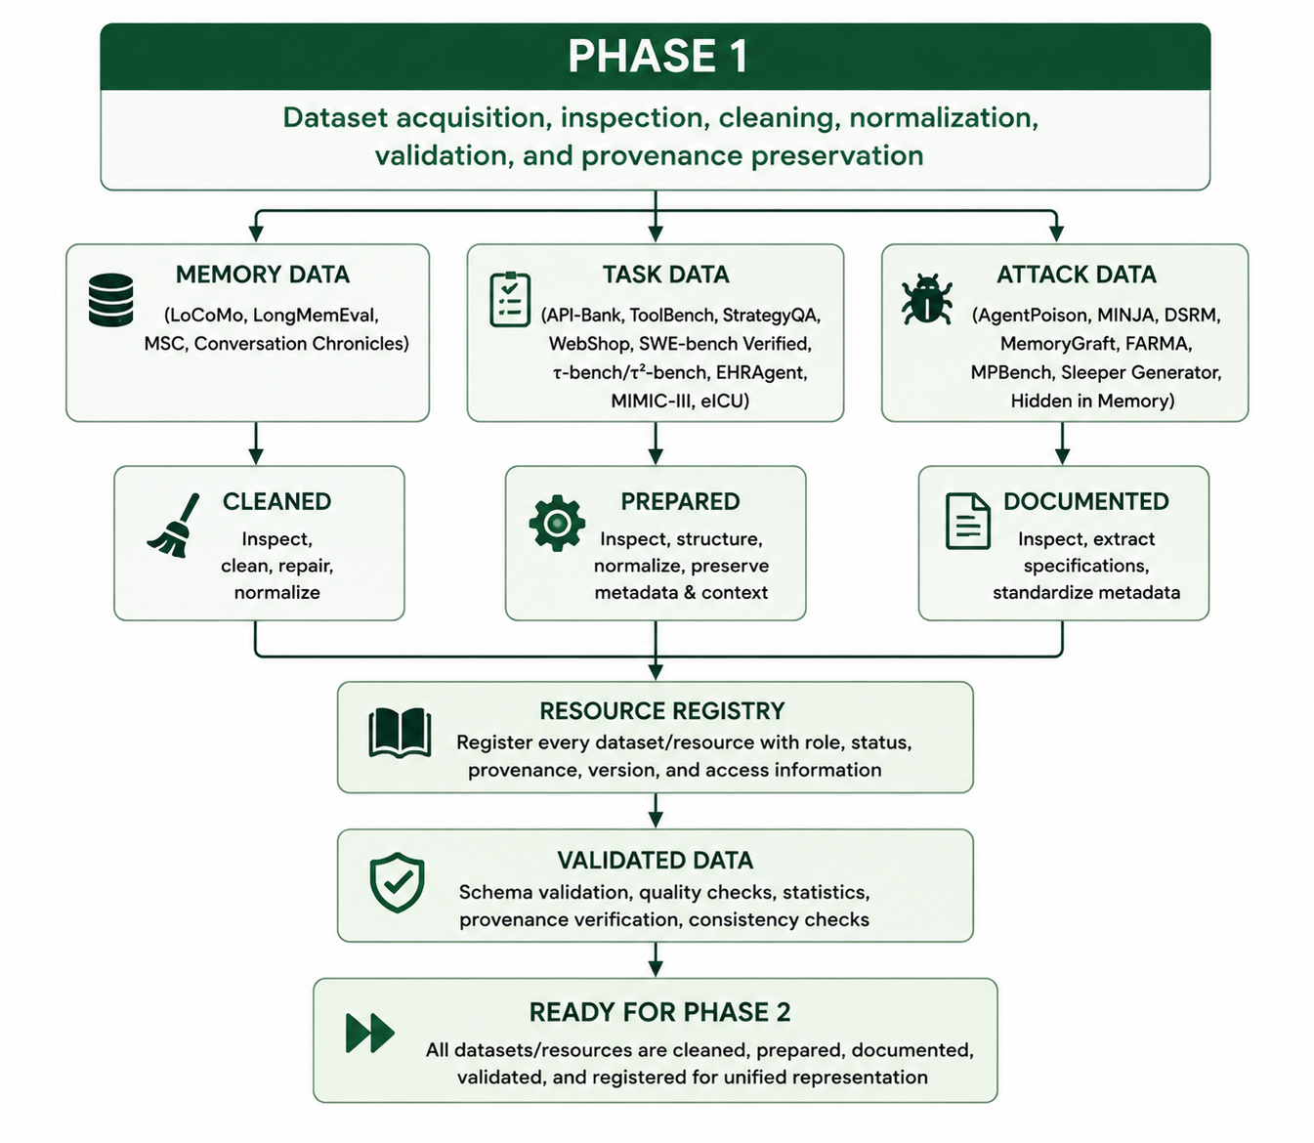

NOTE: We are not blindly cleaning the datasets by deleting every malformed or unusual record. Instead, Phase 1 carefully inspects and classifies data quality issues, distinguishing valid, repairable, flagged, and genuinely unusable records. Anything removed is preserved and documented with its reason and provenance. This is important because understanding natural data noise and distinguishing it from malicious poisoning is itself a key part of our research.

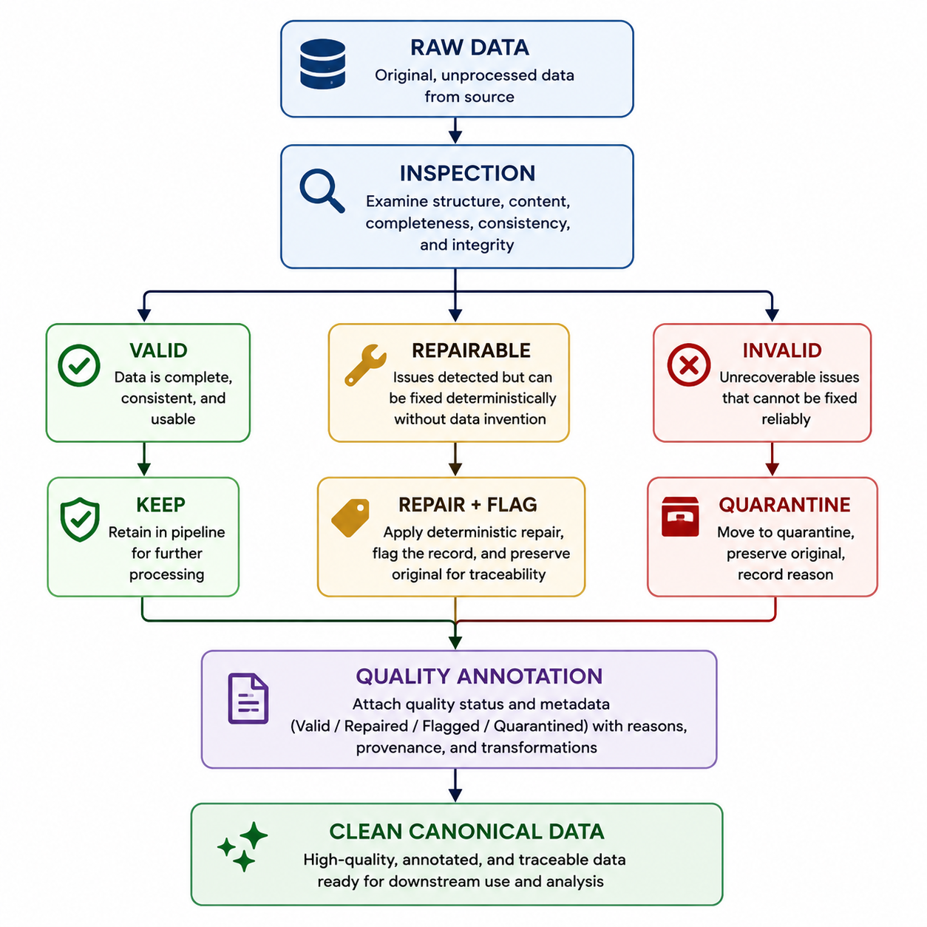

RESULT:
Phase 1 established the data foundation for the entire MAMBench project: LoCoMo, LongMemEval, MSC, and Conversation Chronicles were acquired, cleaned, normalized, validated, and made provenance-aware, with malformed records carefully classified as valid, repaired, flagged, or quarantined rather than silently deleted. We also prepared API-Bank, StrategyQA, SWE-bench Verified, τ-bench, and τ²-bench, while inspecting the remaining workload, attack, and security resources and documenting their accessibility and reproducibility. For the sleeper component, we obtained the Hidden in Memory resource for inspection and retrieved the Sleeper Dataset Generator materials, including the available sleeper-agent few-shot templates; we then prepared a reproducible generator configuration/template system that can later create controlled sleeper scenarios with specified triggers, contexts, labels, and seeds, but we did not generate the final experimental sleeper dataset yet. A 28-entry resource registry, provenance tracking, quarantine system, reproducible preprocessing pipeline, and 53/53 passing tests were established. The main outstanding issues are the undownloaded LongMemEval m_cleaned, Conversation Chronicles sampling, unclear MSC licensing, two source-corrupted LongMemEval records, unverified DSRM, several inspected-but-not-acquired resources, and access-dependent MIMIC-III/eICU. Overall, Phase 1 is PASS WITH ISSUES: the data foundation is clean, traceable, reproducible, and ready to support Phase 2.

